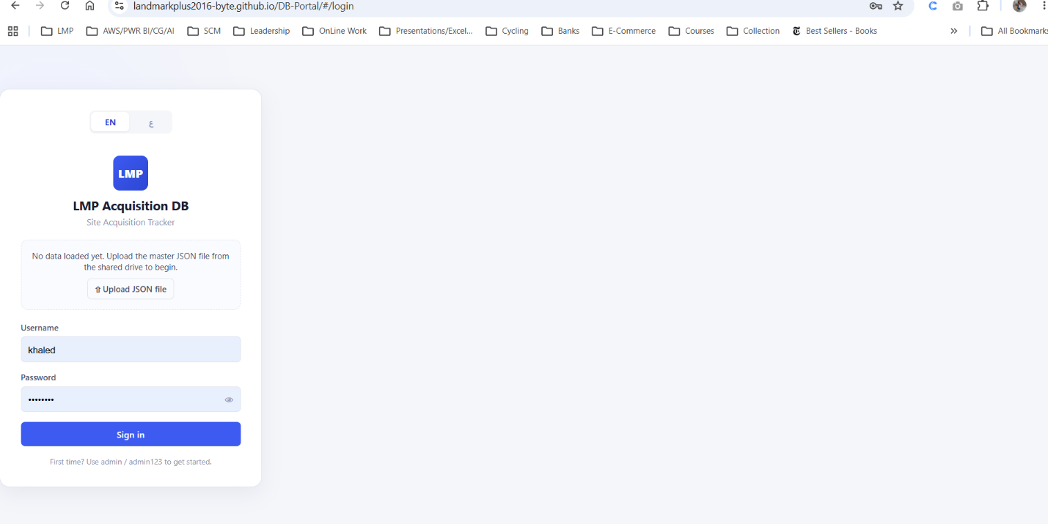
Need the login to be in the center of the screen

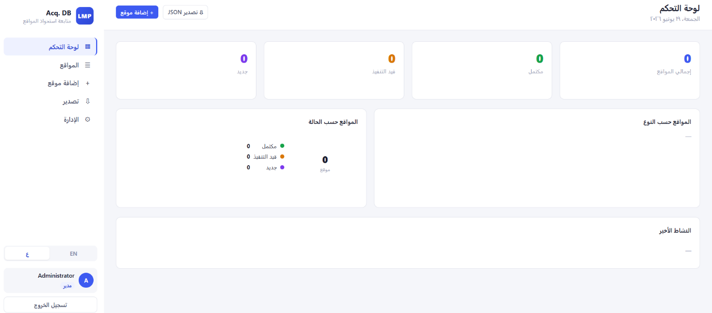
The side bar is not moving to the right when I switch to arabic

